



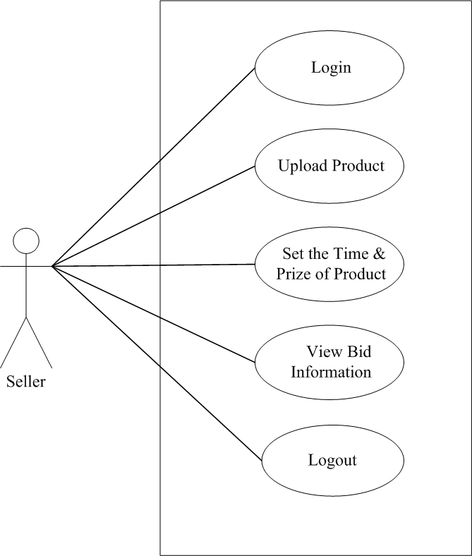

**Table**

Table Name: Login

Description : It Store users Detail.

|  |  |  |
| --- | --- | --- |
| **Column Name** | **Data Type** | **Constraint** |
| username | Nvarchar | Primary key |
| pwd | Nvarchar |  |

Table Name: User_Master

Description : It Store users Detail.

|  |  |  |
| --- | --- | --- |
| **Column Name** | **Data Type** | **Constraint** |
| FirstName | Nvarchar | Primary key |
| LastName | Nvarchar | Not Null |
| Gender | Nvarchar | Not Null |
| Address | Nvarchar | Not Null |
| Country | Nvarchar | Not Null |
| State | Nvarchar | Not Null |
| City | Nvarchar | Not Null |
| E-Mail | Nvarchar | Not Null |
| E-Mail | Nvarchar | Not Null |
| Photo | Nvarchar | Not Null |

Table Name: Category_Master

Description : It Store Category Detail.

|  |  |  |
| --- | --- | --- |
| **Column Name** | **Data**  **Type** | **Constraint** |
| Cat_id | Int | Primary key |
| CatName | Nvarcha |  |

Table Name: Bid_Master

Primary Key : Bid_id

Foreign Key : Product_id , Username

Description : It Store Bidding Detail.

|  |  |  |
| --- | --- | --- |
| **Column**  **Name** | **Data Type** | **Constraint** |
| Bid_id | Int | Primary key |
| Product_ id | Int | Foreign key |
| Username | Nvarchar | Foreign key |
| Bid_Date | Datetime |  |
| Bid_Price | Numeric |  |

Table Name: Product_Master

Primary Key : Product_id

Foreign Key : Cat_id , Username

Description : It Store seller and bidder Can upload product and Detail.

|  |  |  |
| --- | --- | --- |
| **Column**  **Name** | **Data Type** | **Constraint** |
| Product_id | Int | Primary key |
| Cat_id | Int | Foreign key |
| Username | Nvarchar |  |
| ProductName | Nvarchar |  |
| Description | Nvarchar |  |
| Min_Bid_Price | Numeric |  |
| Status | Bit |  |
| Photo | Nvarchar |  |
| StartDate | Datetime |  |
| EndDate | Datetime |  |

Table Name : feedback_Master

Primary Key: News_id

Foreign Key :

Description : It Store News Detail.

|  |  |  |
| --- | --- | --- |
| **Column Name** | **Data Type** | **Constraint** |
| F_id | Int | Primary key |
| Firstname | Varchar |  |
| Email | Nvarchar |  |
| Contact | Varchar |  |
| Subject | Nvarchar |  |
| Msg | Nvarchar |  |